A000-Asia-China-Shang-Zun-Bronze-1600-1046 BCE

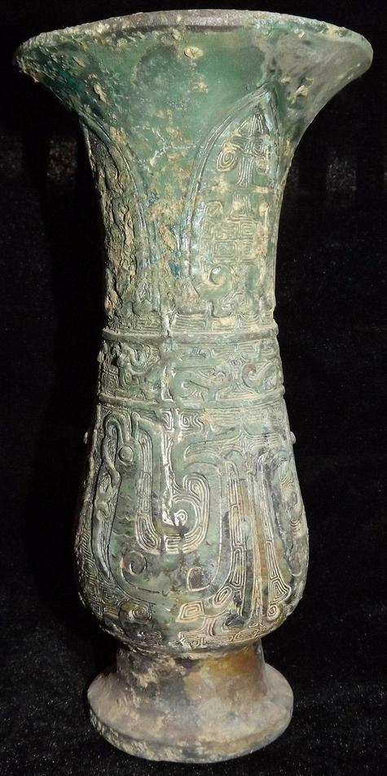

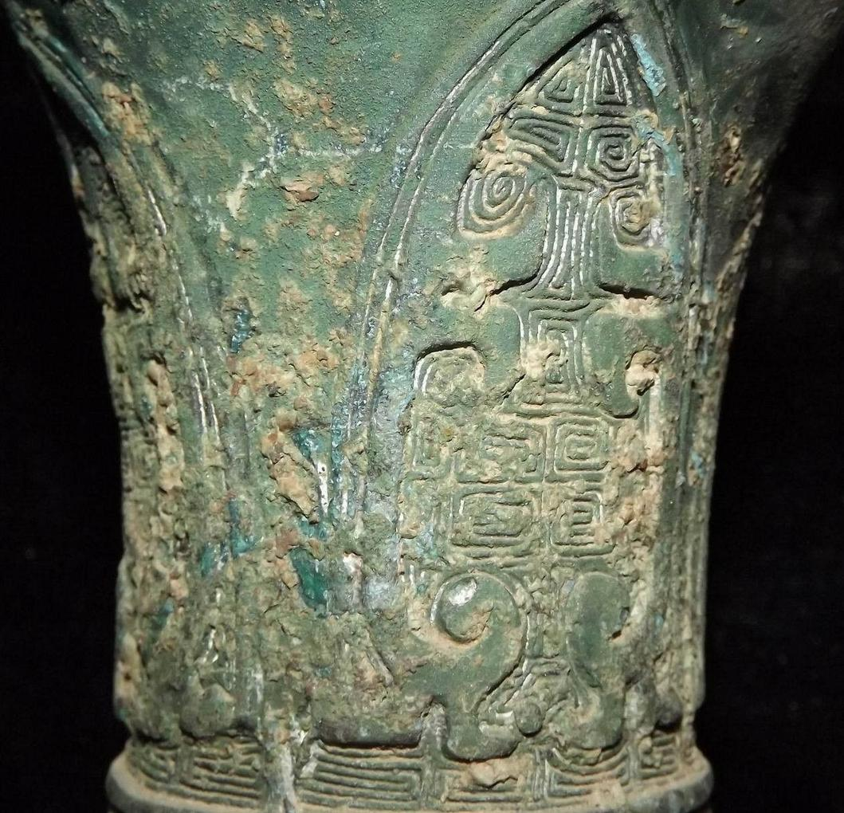

Tree of Life

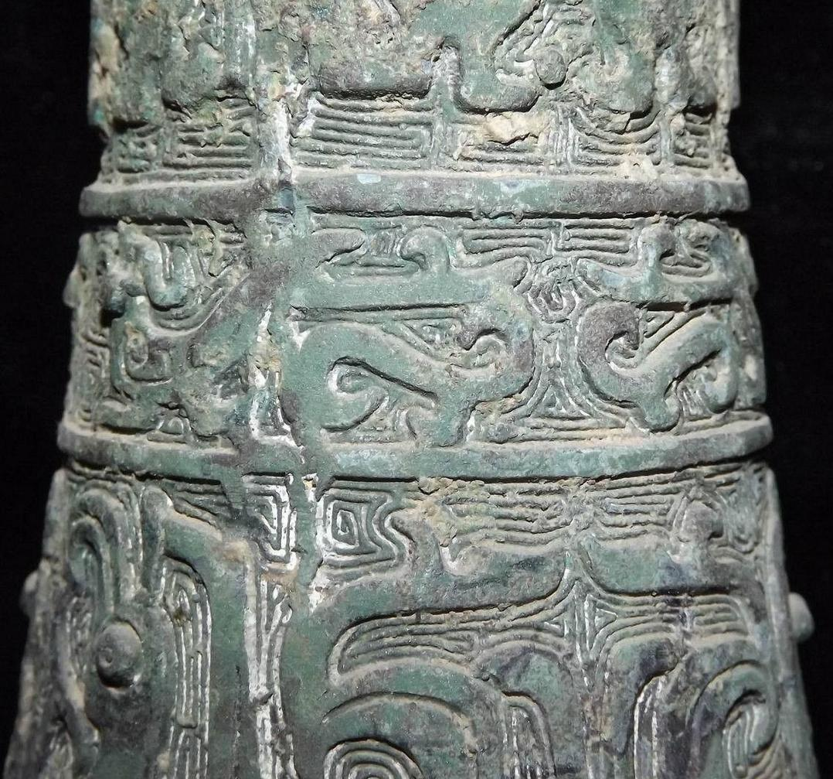

Stylized tigers and dragons

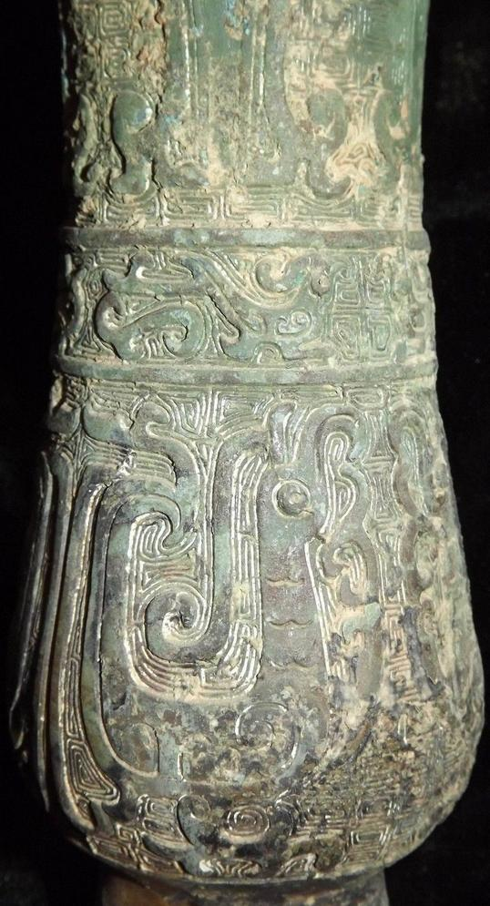

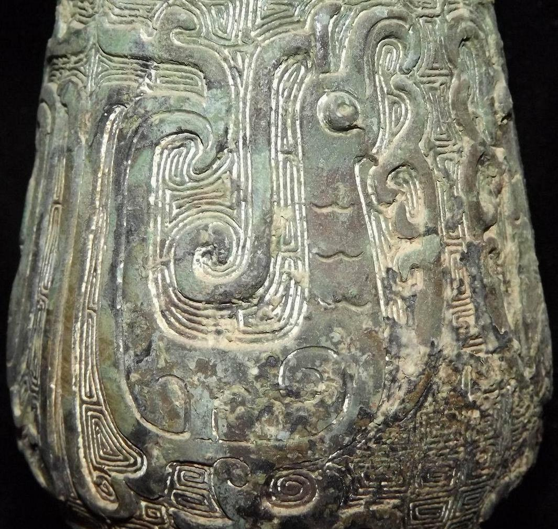

Rising Phoenix-like bird-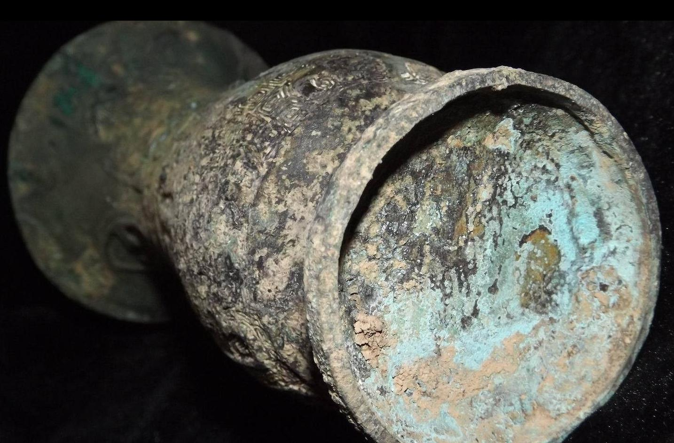

Figs. China-Shang-Zun-Bronze-1600-1046 BCE

Case No.: 5

**Accession No.**

**Formal Label:** China-Shang-Zun-Bronze-1600-1046 BCE

**Display Description:**

**This is an unusual zun with many stylized motifs including tigers, dragons and a magnificent phoenix-like bird. A so-called tree of life appears surmounting a complex motif.**

**LC Classification:**

**Date or Time Horizon:**

**Geographical Area:**

**Map:**

**GPS coordinates:**

**Cultural Affiliation:**

**Medium: bronze**

**Dimensions:**

**Weight:**

**Condition:**

**Provenance:**

**Discussion:**

**References:**